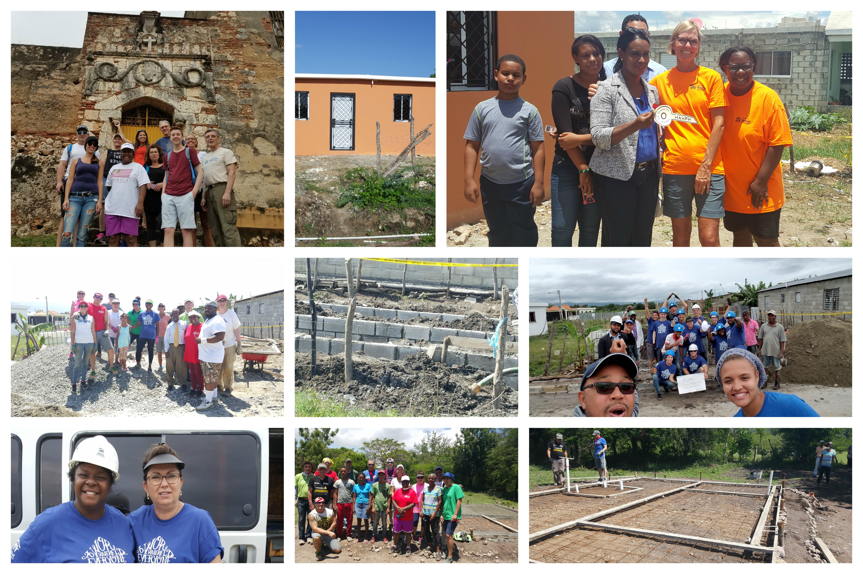

Words used to describe the build experience: amazing, gratitude, overwhelming, life changing, incredible, humbling, grateful and blessed!

During the week of April 23, Hartford Habitat supported our sister affiliate in Dominican Republic. Dominican Republic is saturated with love that flows from the ocean to the valleys. It also has a great level of need and a housing crisis. We worked with two families this week and concluded our build with a house blessing and key ceremony. Although we were miles away from home, the dedication had the same spirit of joy, appreciation, gratitude and accomplishment. We also had the opportunity to share this beautiful build and dedication with Dr. Moyer’s family. ***The mission is the same all over the world…to build simple decent housing for God’s people in need.***

Hartford Habitat

Builds in the Dominican Republic