July Board Update

Finance and Development
- We closed on all six properties in June. Main Street (3 new construction), Cleveland, Waverly and Farmington (3 recycled properties).
- We maintained our 4 star rating from Charity Navigator. This is our 4th year. This is important to potential donors because it evaluates the affiliate’s fiscal management
- The Impact Team had our first meeting on July 11th with Netmark Associates/Judith Green. We will be finalizing our roadmap in August.
- Audit will begin on August 28th and they will be on site for about two weeks.

Construction and ReStore
- South Marshall is moving along with all roofs on the duplexes. Groups are currently siding, installing windows and subs are doing rough ins. All utility work will be completed by the end of the month.
- Foundations will be installed by the first week of August in East Hartford. Bliss and Moore (2 foundations)
- New Britain will have permits in two weeks and will have foundations in the ground by August 30th
- BAT will be in East Hartford, New Britain and Hartford.
- ReStore continues to meet daily sales, engaging more volunteers and maintaining expenses.

Family Services/Financial Freedom Center
- We will host our facilitator training in late August. August 30, 31st. Noon, 3pm and 6pm each day.
- Classes will be held in September, October and first half of November 2017.
- We are meeting with the condo owners in August and will have an update for the September board meeting.
- We met with United Bank to discuss our loan servicing agreement and will be making some changes to accommodate the bank.
- Lisa, Scott and I are scheduled to meet with Hartford Foundation for Public Giving regarding the three year operations grant on August 2nd.

Personnel
- On June 28th, our team including interns went to Adventure Rooms to finalize our communication/team building training.
- Kris McKelvie started with us on this past Monday and is our Director of Construction. Kris has several years of Habitat experience and will bring a high level of organization, planning and construction skills. Kris started his Habitat career with our affiliate as an Americorps member, then Construction Supervisor (completing South Marshall I).
- Rose Vigdal started with us on July 10th and will head our Individual Engagement. Rose has fundraising, event management and advocacy experience. She has raised thousand of dollars for Alzheimer's and will now bring those skills back to Habitat. Rose is also a homecoming for the affiliate; she managed our Stanley Store in New Britain for seven years.

Finally, we have four interns this summer.
- Rickwan is a high school student and is working with Construction.
- Sophia is an incoming freshman at Yale and she is working with Finance and the Development team.
- Nymiah is a junior at Central College. She is working with Tracy in Family Services.
- Brittany is a junior at Highpoint College and is working at the ReStore.
Affiliate Events-Mark your calendars
- August 28th-Golf Tournament and Cocktail Party
- September 6-Board Meeting
- September 12/27- Impact Team Presentation of Draft Road Map
- September 18-30 Build A Thon
- October 18-Volunteer Appreciation at Mark Twain 5pm-7pm
- December 5-Board Meeting at Town and County

Board Updates
- Congratulations! The board met Lisa’s generous challenge and donated $5,000 to close out the fiscal year.
- Lisa, Tom, Don and Christina attended the Carter Work Project in Canada.
- Reminder that I have open availability during the week of July 31st to provide tours and have in depth discussions regarding the various arms of the Habitat mission. Feel free to reach out with a date and time. If that week doesn’t work then we can find another day.
- Current appointments/topics with Board members

July 31st  Noon  Topic/Location  not finalized yet. | August 1st  8am-10am  (Open Time-just stop by)  75 Charter Oak Office  How to host a dedication or pitching the Habitat 101 | August 3rd  10:00-Noon  Tour ReStore and Habitat Neighborhoods  (Bloomfield, Hartford, New Britain) | September 18  8:30-9:30am  780 Windsor Street  Financial Freedom Center

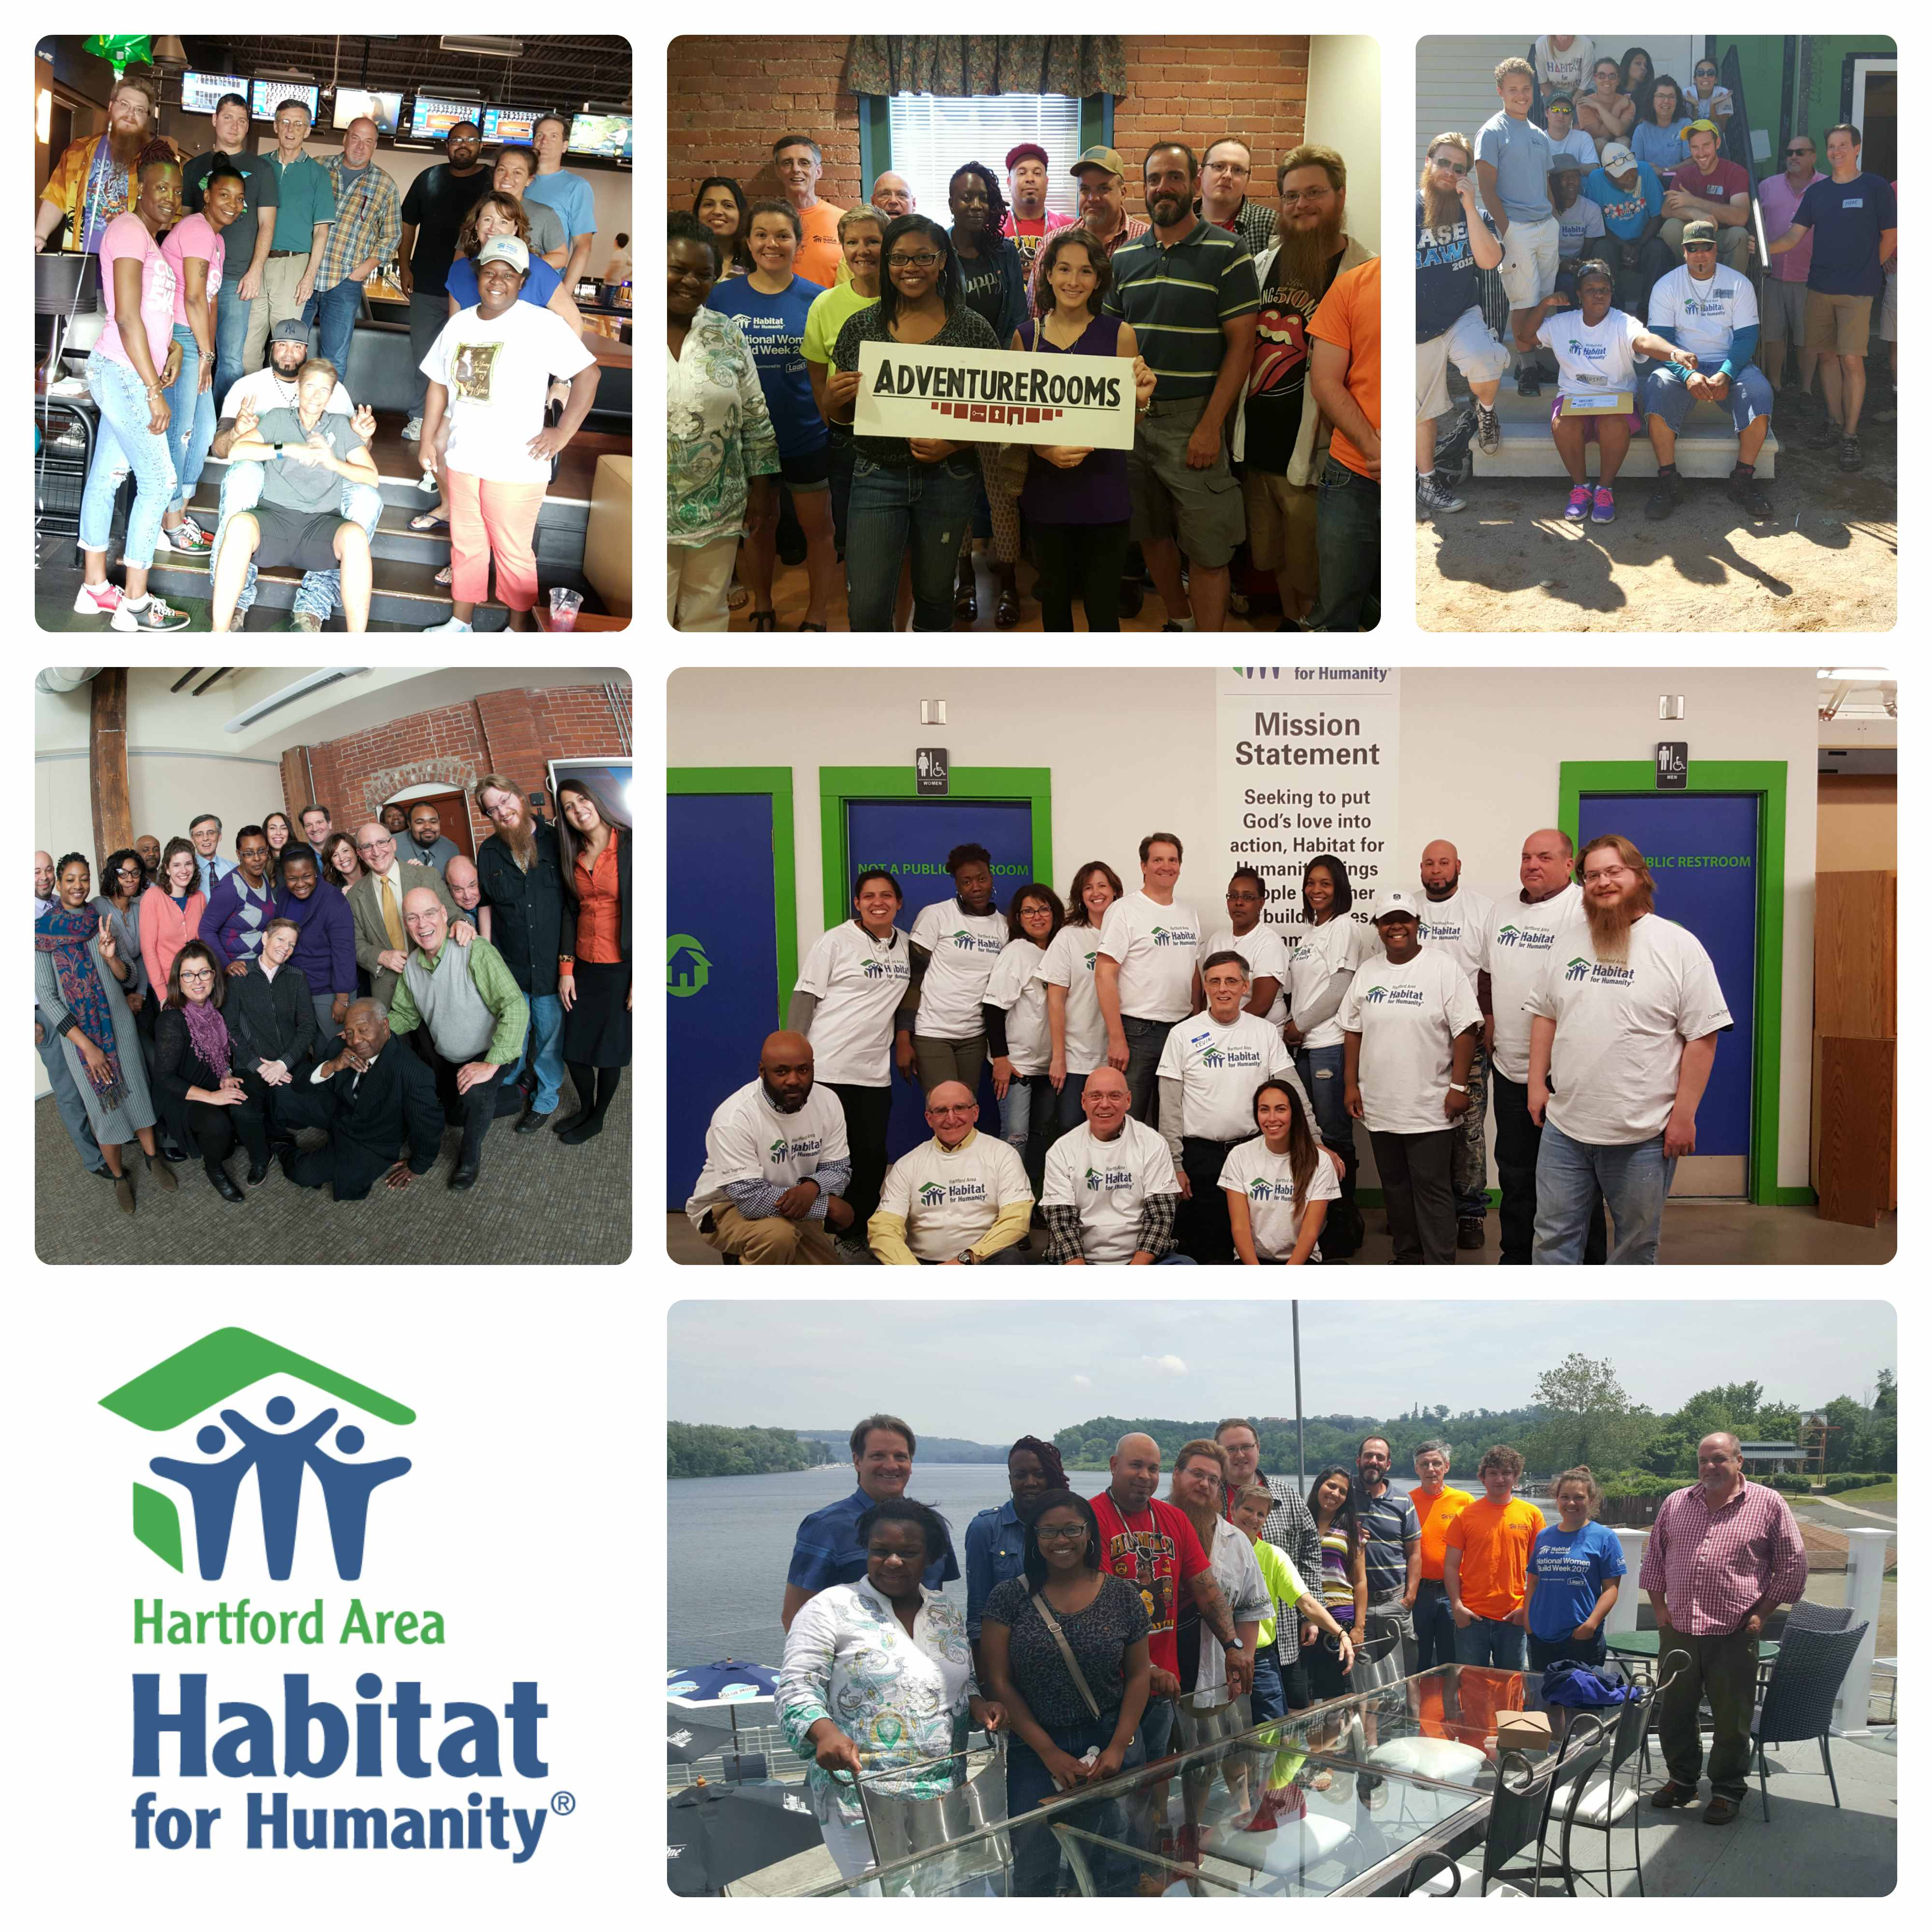
Visit Spotify to check out our staff Playlist of favorite songs!
Hope you enjoy!

